**Problem Statement**

Design a system for the bank to communicate with its customers in a cost effective manner

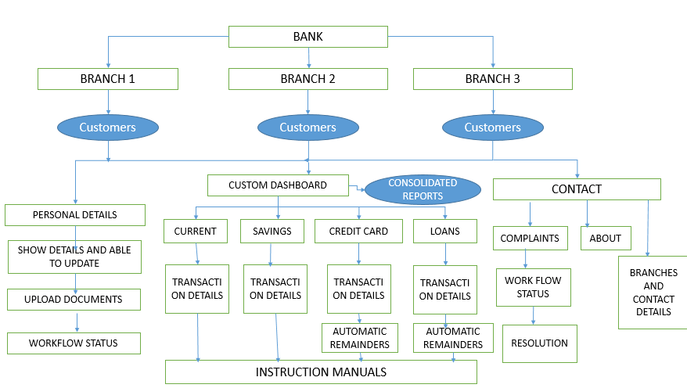

**Online Account Creation Request and Work flow status**

1. Customer should be able to open the account online by filling all the necessary details and uploading documents. A work flow status should be displayed such that customer knows the exact status of the application. This reduces the time taken via normal approach.

This saves the time of the bank employee as well as customer and also enhances customer experience. Also there will be cost reduction in terms of papers, printing and reduced effort of employee to add the details into the system

**Customer’s personalized settings**

1. Let the customer choose the preferred way of communication (email/call back/ sms).
2. Provide an option for Customer’s preferred language

These help in handling the information well. Also storing preferred language helps in redirecting calls to specific people from that language which reduces delay in the process.

**Creating and Personalizing Bank Statements and Statements Available on Demand**

1. For enhancing customer experience we need to have a user interface for the customer such that the customer chooses what is to be displayed on the home screen.
2. Create personalized and consolidated statements having details of customers multiple accounts including Current, Savings, Credit card transactions and Loan details. This statements should be available both in print (downloadable) and electronic form (view). This enhances the customers experience and reduce number of requests from the customers. As a result the utilization of man power can be less for this process.

By this process, the customers prefer to download the soft copy of the transactions. This helps in saving the cost of paper, printing and postal charges.

Also the customer don’t need to contact bank to get these details, such that manual effort of calls from customers is reduced.

**Work flow status**

1. Have a dashboard to display the work flow status for a request from the customer. This helps in reduced number of calls from the customers.
2. Send an automated message when the work flow status changes.

This helps in utilizing technology over the legacy process and helps in reducing the time for customer support which is great advantage. A lot of time is saved as there will not be need for answering the calls.

**Welcome Kits**

1. Bank need to provide welcome kits that includes all the instructions and details regarding Accounts, Credit cards, Loans and all required details which are easy to understand.

This helps in such a way that the customer checks the documents whenever he gets a doubt in any of the process. The process of getting details from the bank support will get reduced, which in turn reduces the effort and save time.

**Automated remainders and acknowledgements**

1. An automated email/sms needs to be sent whenever a deadline is approaching for payment of debts/loans.
2. Automated acknowledgement whenever a payment is received.
3. Automated acknowledgement with a reference number whenever a request/complaint is raised.

This helps in such a way that bank support need not call the customer to inform the details. This saves effort, time and call costs.

**Detailed transaction details**

The transaction details should be very clear in such a way that it displays the date, transaction reference number, To whom the transaction is done/purchase details, From which account the amount has been deducted(if customer has multiple accounts).  
  
As most of the calls to the banks are related to transactions in their account, a detailed statement of transactions will reduce a lot of effort.

**Credit cards**

1. A detailed document should be available w.r.t credit card clearly stating the plans, annual amount, amount needs to be spent in a financial year etc.
2. When making a purchase a detailed list of EMI options should be available such that customer chooses the appropriate plan.
3. Automated remainder of payment for credit card.

A lot of calls will be w.r.t credit cards asking for due date, minimum balance payment and when it is to be paid etc. This reduces the effort and save time.